

**Specification**

**for**

**05/12/10**

IderaLogo

Proprietary and Confidential to BBS Technologies, Inc.

**© 2010 BBS Technologies, Inc.; all rights reserved.**

# Revision history:

|  |  |  |
| --- | --- | --- |
| **When?** | **Who?** | **What?** |
| 05/12/2010 | Robert | First Draft |

# Table of Contents

1. Revision history: ii

2. Table of Contents iii

3. Requirements 1

3.1. Overview/Purpose 1

3.1.1. Related Customer Requests 1

3.2. Use Cases 1

3.3. Feature/Function Market Requirements 1

3.3.1. Required Functions 1

3.3.2. Non-Supported Functions 2

3.4. Open Questions 2

4. Functional Design 3

4.1. User Interfaces 3

4.2. Installation and Upgrade 5

4.3. Permissions and other Required Configuration 5

4.4. Licensing Issues 5

4.5. Dependencies 5

4.5.1. Dependencies on Idera Software 5

4.5.2. Third-Party Software Required on the Customer Machine 5

4.5.3. Third-Party Software Required Internally 5

5. Internal Design 6

5.1. Architecture 6

5.2. Installation Issues 6

5.3. Schedule 7

5.3.1. Work Breakdown and Sizings 7

5.3.2. Areas of Risk 7

6. Quality Assurance Considerations 7

7. Documentation Considerations 7

8. Bibliography 7

# Requirements

## Overview/Purpose

Many customers have setup linked servers and have requested the ability to move those links from one server to another. But in many cases, the passwords are no longer available or known. A new tool, Linked Server Mover, will be created to allow users to move linked server links from one server to another.

### Related Customer Requests

1597 – FRQ: Ability to move/copy Linked Servers in a similar manner to logins, jobs etc

1520 – FRQ: Support for handling linked servers

1494 - Request for a new tool that will enumerate all linked servers on any/all registered servers

All three PRs deal with wanting to display and move the linked servers.

## Use Cases

1. Users should be able to view all the Linked Servers for an instance.
2. Users should be able to move one or more Linked Server connections.
3. Users should be able to see exisiting Linked Servers.
4. Users should be able to specifify a the source instance.
5. Users should specifiy the destination instance
6. Users should be able to view the properties of a selected Linked Server.

## Feature/Function Market Requirements

### Required Functions

#### Basic Workflow

From a user perspective, this is a very straight forward tool.

The workflow is a follows:

1. The user will select a source server.
2. The user will select destination server.
3. The user clicks view Linked Servers. A list of currently linked servers will be displayed.
4. The user will then select the Linked Servers to be moved and click ‘Move Linked Servers’.

If the user so desires, they can also view the properties of the Linked Server either double clicking the server or right clicking on the server and selected properties.

This is tool is a copy only tool. The Linked Servers will be duplicated from Instance A to Instance B.

### Non-Supported Functions

1. This tool will not allow the user to modify the settings for a linked server. This tool will only move them.

## Open Questions

1. Should this tool allowing copying and moving or just copying?

# Functional Design

## User Interfaces

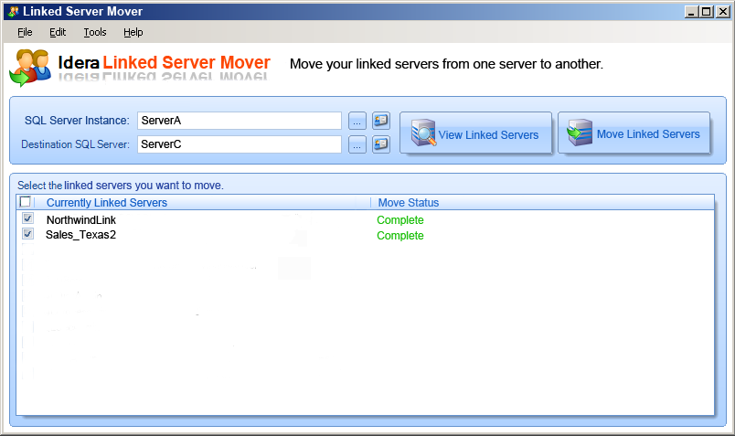

Linked Server Properties dialog..

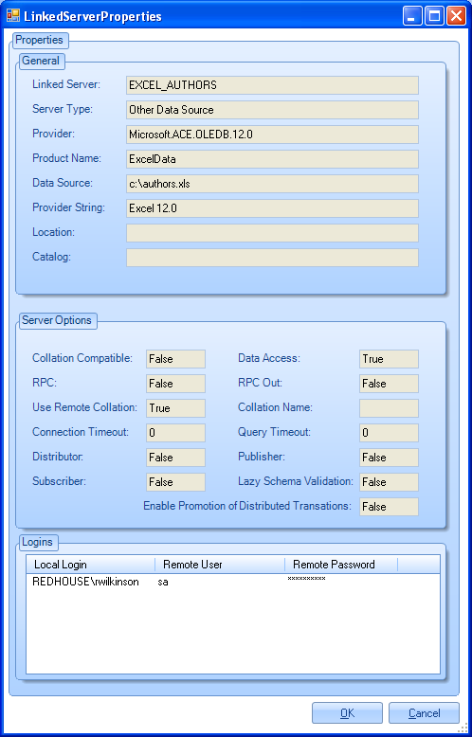

## Installation and Upgrade

None

## Permissions and other Required Configuration

The user most have access to create Linked Servers on the destination server.

## Licensing Issues

None

## Dependencies

None

### Dependencies on Idera Software

None

### Third-Party Software Required on the Customer Machine

This tool will use Devcomponents Dotnetbar.

### Third-Party Software Required Internally

None

# Internal Design

## Architecture

An overview of the architecture behind this feature – how it works, components, communication between components etc

The list of Linked Server:

SQL Server 2000

sysservers where isremote = 1

SQL Server 2005/2008

sys.servers where is_linked=1

The list of Linked logins:

SQL Server 2000

sysoledbusers where rmtsrvid = srvid from sysservers

SQL Server 2005/2008

sys.linked_logins where server_id = server_id from sys.servers

The login information (username/password):

SQL Server 2000

sysxlogins where srvid = srvid from sysoledbusers

SQL Server 2005/2008

syslogins where name = remote_name from sys.linked_logins

sp_addlinkedserver – to add a linked server (2000/2005/2008)

sp_addlinkedsrvlogin – add a linked server login (2000/2005/2008)

sp_serveroption – sets the linked server options (2000/2005/2008)

## Installation Issues

None.

## Schedule

### Work Breakdown and Sizings

|  |  |  |
| --- | --- | --- |
| Component | Who | Sizing (Days) |
| User Interface | Robert | 5 |
| Implementing the core functionality | Robert | 5 |
| Integration into the launchpad and testing | Robert | 5 |
| **Total** |  | **15** |

### Areas of Risk

None

# Quality Assurance Considerations

This is a new untested tool.

# Documentation Considerations

This is a new tool and will need to be documented from scratch.

# Bibliography